AGENT REFERENCE GUIDE: REDCAL LITE FILE
Date: | 2/29/2024

Overview
The RedCal Lite file was implemented to improve the communication between Agents and DTC’s Announcements team. The RedCal Lite files are standardized Excel spreadsheets, designed for Agents to provide DTC with standardized notification for both upcoming redemption events and modifications to existing redemption events. The file enables the DTC Announcements team to announce and/or update distribution events timely and accurately.

This document describes how Agents must use the file to notify DTC’s Announcements team with announcement detail for new and existing redemption events. Notification must be provided to the relevant mailbox and within the time frames outlined within the terms of DTC’s Operational Arrangements, available on DTCC’s website.

DTC Agent File Detail Input
The spreadsheets have several fields that must be updated in order to permit DTC to systemically process files through its systems. The details for the fields are listed below for your reference.
There are two files that are to be used, one for bonds/debt instruments and one for equities/preferred stocks/UD’s/UIT’s. Note that, under no circumstances, can files sent to DTC include both debts and equities due to the unique denomination characteristics of debts and equities., Debts and Equities must be sent separately using the appropriate file/s.
These files must be saved in Excel Workbook Format (.xlsx) only.
If providing event notification or rate information for Bonds/Debt Securities that pay per $1,000, the following REDCAL Redemption Notification template is to be used:

Below is a guide explaining what information is required within each field and whether or not it is required.
Field Name | Description | Key Note
CUSIP | Security identifier associated with the event | Required field
Call Type | Indicates whether the event is a Partial Call, Full Call or Final Principal Paydown. | Required field
Redemption Date | Date of redemption payment | Required field
Publication Date | Date that the redemption is published. Transfer of ownership will stop and the lottery is run on this date for partial calls. | Required field
Principal Rate | Rate of principal paid (provided as a %) | Required field
Principal Distribution Per 1000 | Principal rate per 1000 | Required field – if the rate is unknown at the time of notification please leave blank
Accrued Interest Per 1000 | Off cycle interest rate per 1000 | Required for off cycle interest events – if the rate is unknown at the time of notification please leave blank.
Agent # | Agent number – used to identify the address that certificates or payment instructions must be sent to | Required field – please provide either DDA or Redemption Agent Number
Certificate Prefix | Prefix – for agent use only | Required for Partial Calls only on non-fast certificated issues
Certificate Number | Certificate number to be redeemed (if applicable) | Required for Partial Calls only on non-fast certificated issues
Called Amount | Position amount to be redeemed. | Required field
Conditional Indicator | Indicates if the redemption is dependent on another event.  If yes, add “Y”  If no, leave the field blank | Optional field
Revision Indicator | Indicates if there is an existing announcement that needs to be modified.  If yes, add “R”  If no, leave the field blank | Optional field

If providing event notification or rate information for Equity/Preferred Stock/UD/UIT securities, the following REDCAL Redemption Notification template must be used:

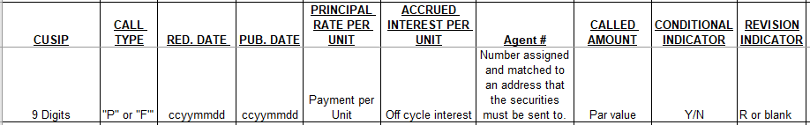
Below is a guide explaining what information is required within each field and whether or not it is required.
Field Name | Description | Key Note
CUSIP | Security identifier associated with the event | Required field
Call Type | Indicates whether the event is a Partial Call or Full Call. | Required field
Redemption Date | Date of redemption payment | Required field
Publication Date | Date that the redemption is published. Transfer of ownership will stop and the lottery is run on this date for partial calls. | Required field
Principal Rate per Unit | Rate of principal paid per unit | Required field
Accrued Interest Per Unit | Off cycle interest or dividend rate per unit | Required for off cycle interest events only  On cycle interest must not be included
Agent # | Agent number – used to identify the address that certificates or payment instructions must be sent to | Required field – please provide either DDA or Redemption Agent Number
Called Amount | Position amount to be redeemed. | Required field
Conditional Indicator | Indicates if the redemption is dependent on another event.  If yes, add “Y”  If no, leave the field blank | Optional Field
Revision Indicator | Indicates if there is an existing announcement that needs to be modified.  If yes, add “R”  If no, leave the field blank | Optional Field

Any questions regarding this guide or the Announcements process/es should be directed via email to redemptionannouncements@dtcc.com.

